### REAL-TIME WATER QUALITY MONITORING AND ANALYSIS SYSTEM

### TEAM MEMBERS

* VISHWA G
* STEVE CHRISTIAN SAMUEL CS
* SUNDARESH S
* SANGEETH KUMAR LM

### Aim

To design and develop a real-time water quality monitoring system using a turbidity sensor interfaced with an ESP8266 microcontroller. The system will continuously measure the turbidity of a water sample, process the data, and display the resulting Nephelometric Turbidity Units (NTU) on an I2C OLED screen, providing an immediate visual assessment of water clarity.

### Apparatus Required

* ESP8266 (NodeMCU) Microcontroller
* Water Turbidity Sensor Module
* I2C OLED Display Module (0.96 inch, 128x64)
* Breadboard
* Jumper Wires
* 5V Power Supply

### PIN TABLE

|  |  |
| --- | --- |
| **Component Pin** | **ESP8266 (NodeMCU) Pin** |
| Turbidity Sensor VCC | 5V (Vin) |
| Turbidity Sensor GND | GND |
| Turbidity Sensor AOUT | A0 |
| OLED Display VCC | 3.3V |
| OLED Display GND | GND |
| OLED Display SDA | D2 (GPIO4) |
| OLED Display SCL | D1 (GPIO5) |

### COMPONENT DESCRIPTIONS

### ESP8266

The ESP8266 is a low-cost Wi-Fi-enabled microcontroller. Its powerful processing capabilities and onboard Wi-Fi make it an excellent choice for Internet of Things (IoT) projects, allowing for remote monitoring and data logging. The NodeMCU development board provides easy access to its GPIO pins, including an analog-to-digital converter (ADC) for reading analog sensors.

### Turbidity Sensor

A turbidity sensor measures the cloudiness or haziness of a fluid caused by suspended solid particles. It typically operates by emitting a light beam into the sample and measuring how much light is scattered by the particles. The sensor returns an analog voltage proportional to the turbidity, which can be converted into Nephelometric Turbidity Units (NTU) to quantify water quality.

### I2C OLED Display

An I2C OLED (Organic Light-Emitting Diode) is a self-illuminating display technology that offers high contrast, wide viewing angles, and low power consumption. This 128x64 pixel screen uses the I2C communication protocol, requiring only two data lines (SDA and SCL) for communication, which simplifies the wiring process for displaying real-time sensor data.

### FLOW CHART

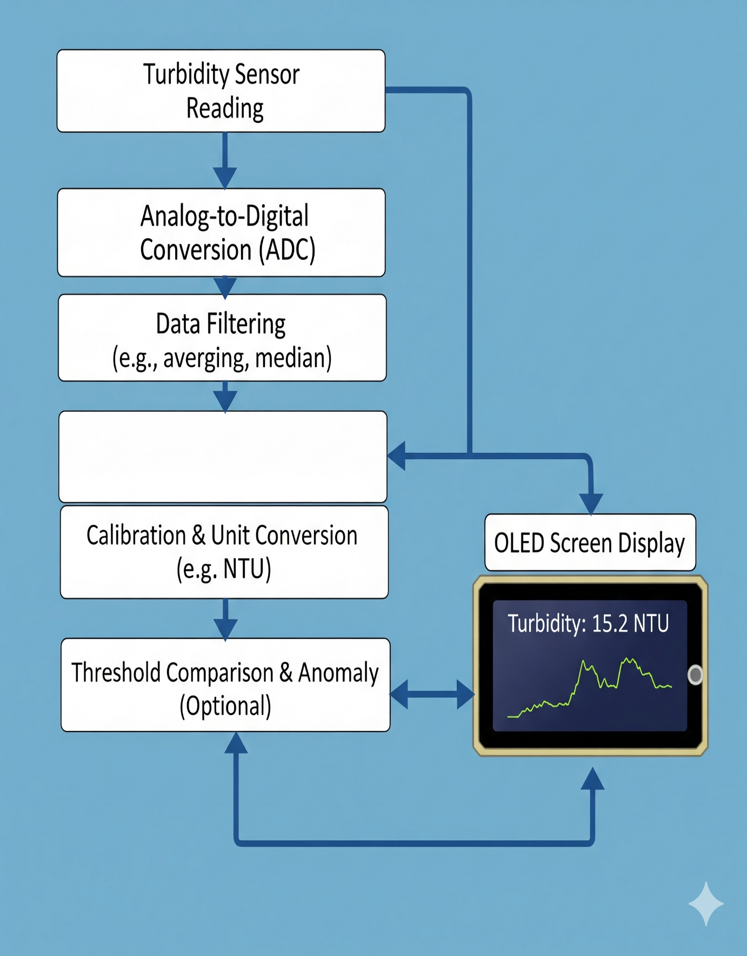

### PROGRAM

#include <Wire.h>

#include <Adafruit_GFX.h>

#include <Adafruit_SSD1306.h>

// --- OLED Display Configuration ---

#define SCREEN_WIDTH 128

#define SCREEN_HEIGHT 64

// OLED reset pin is not used on I2C, so set to -1

Adafruit_SSD1306 display(SCREEN_WIDTH, SCREEN_HEIGHT, &Wire, -1);

// --- Pin Definitions ---

int turbidityPin = A0;  // Turbidity sensor connected to Analog Pin A0

// I2C pins for ESP8266 (NodeMCU)

#define OLED_SDA 4   // D2 on NodeMCU

#define OLED_SCL 5   // D1 on NodeMCU

void setup() {

  Serial.begin(115200);

  // Initialize I2C communication with custom SDA and SCL pins

  Wire.begin(OLED_SDA, OLED_SCL);

  // Initialize the OLED display

  if(!display.begin(SSD1306_SWITCHCAPVCC, 0x3C)) {

    Serial.println(F("SSD1306 allocation failed"));

    for(;;); // Loop forever if display fails

  }

  // Display a startup message

  display.clearDisplay();

  display.setTextSize(1);

  display.setTextColor(WHITE);

  display.setCursor(10, 10);

  display.println("Water Quality");

  display.println("  Monitor");

  display.display();

  delay(2000);

}

void loop() {

  int turbidityValue = analogRead(turbidityPin);

  // ESP8266 ADC has 10-bit resolution (0-1023) and a 3.3V reference.

  float voltage = turbidityValue * (3.3 / 1023.0);

  // NTU standards for accurate readings. The relationship between

  // voltage and NTU is often non-linear.

  float turbidityNTU = -1120.4 * square(voltage) + 5742.3 * voltage - 4352.9;

  if (turbidityNTU < 0) {

    turbidityNTU = 0; // Ensure value does not go below zero

  }

  // Print values to the Serial Monitor for debugging and calibration

  Serial.print("Raw Value: ");

  Serial.print(turbidityValue);

  Serial.print(" | Voltage: ");

  Serial.print(voltage);

  Serial.print("V | Turbidity: ");

  Serial.print(turbidityNTU, 2); // Print with 2 decimal places

  Serial.println(" NTU");

  // --- Display values on the OLED screen ---

  display.clearDisplay();

  display.setTextSize(1);

  display.setTextColor(WHITE);

  display.setCursor(0, 0);

  display.println("Water Quality Monitor");

  display.drawLine(0, 10, 127, 10, WHITE); // Separator line

  display.setTextSize(2);

  display.setCursor(0, 25);

  display.print("Turb:");

  display.setCursor(60, 25);

  display.print(turbidityNTU, 1); // Display with 1 decimal place

  display.println(" NTU");

  display.display();

  delay(1000); // Wait for one second before the next measurement

}

### EXECUTION

